
Demography - Human Population Ecology
A cemetery is an excellent place to study human demography. Demography is defined as "the study of the characteristics of human populations, such as size, growth, density, distribution and vital statistics". Gravestones record the dates of birth and death, which can be used to calculate death rates and draw survivorship curves. A survivorship curve is simply a graphical representation of the chance that an individual will survive from birth to a particular age. By comparing survivorship curves for different periods of time, we may look for historical trends in demography over the decades.
Demographics from local cemeteries can be used, but in order to get a broader scope of life in the US, the world wide web can be used to gather data about birth and death rates all over the country. Many cemeteries now have databases that list all individuals buried there. This is a much faster way than visiting all cemeteries in an area and making assumptions about the overall US population.
Objectives: Once you have completed this lab, you will understand:
1. Some of the basic concepts of population demography
2. How factors such as advances in medicine and environmental protection may have affected human demography over the past 150 years
3. How human demography might change in the future, based on the current socio-political reality and the presence of incurable diseases (such as AIDS)
Methods --- Internet connection and cemetery database found at www.interment.net (collect from different sources)
Data Table I
Females who died before 1950 | Females who died after 1950 | Males who died before 1950 | Males who died after 1950
Death year______  Birth year ______  Age of death _____ | Death year______  Birth year ______  Age of death _____ | Death year______  Birth year ______  Age of death _____ | Death year______  Birth year ______  Age of death _____
Death year______  Birth year ______  Age of death _____ | Death year______  Birth year ______  Age of death _____ | Death year______  Birth year ______  Age of death _____ | Death year______  Birth year ______  Age of death _____
Death year______  Birth year ______  Age of death _____ | Death year______  Birth year ______  Age of death _____ | Death year______  Birth year ______  Age of death _____ | Death year______  Birth year ______  Age of death _____
Death year______  Birth year ______  Age of death _____ | Death year______  Birth year ______  Age of death _____ | Death year______  Birth year ______  Age of death _____ | Death year______  Birth year ______  Age of death _____
Death year______  Birth year ______  Age of death _____ | Death year______  Birth year ______  Age of death _____ | Death year______  Birth year ______  Age of death _____ | Death year______  Birth year ______  Age of death _____
Death year______  Birth year ______  Age of death _____ | Death year______  Birth year ______  Age of death _____ | Death year______  Birth year ______  Age of death _____ | Death year______  Birth year ______  Age of death _____
Death year______  Birth year ______  Age of death _____ | Death year______  Birth year ______  Age of death _____ | Death year______  Birth year ______  Age of death _____ | Death year______  Birth year ______  Age of death _____
Death year______  Birth year ______  Age of death _____ | Death year______  Birth year ______  Age of death _____ | Death year______  Birth year ______  Age of death _____ | Death year______  Birth year ______  Age of death _____
Death year______  Birth year ______  Age of death _____ | Death year______  Birth year ______  Age of death _____ | Death year______  Birth year ______  Age of death _____ | Death year______  Birth year ______  Age of death _____
Death year______  Birth year ______  Age of death _____ | Death year______  Birth year ______  Age of death _____ | Death year______  Birth year ______  Age of death _____ | Death year______  Birth year ______  Age of death _____
Death year______  Birth year ______  Age of death _____ | Death year______  Birth year ______  Age of death _____ | Death year______  Birth year ______  Age of death _____ | Death year______  Birth year ______  Age of death _____
Death year______  Birth year ______  Age of death _____ | Death year______  Birth year ______  Age of death _____ | Death year______  Birth year ______  Age of death _____ | Death year______  Birth year ______  Age of death _____
Death year______  Birth year ______  Age of death _____ | Death year______  Birth year ______  Age of death _____ | Death year______  Birth year ______  Age of death _____ | Death year______  Birth year ______  Age of death _____
Death year______  Birth year ______  Age of death _____ | Death year______  Birth year ______  Age of death _____ | Death year______  Birth year ______  Age of death _____ | Death year______  Birth year ______  Age of death _____
Death year______  Birth year ______  Age of death _____ | Death year______  Birth year ______  Age of death _____ | Death year______  Birth year ______  Age of death _____ | Death year______  Birth year ______  Age of death _____
Death year______  Birth year ______  Age of death _____ | Death year______  Birth year ______  Age of death _____ | Death year______  Birth year ______  Age of death _____ | Death year______  Birth year ______  Age of death _____
Death year______  Birth year ______  Age of death _____ | Death year______  Birth year ______  Age of death _____ | Death year______  Birth year ______  Age of death _____ | Death year______  Birth year ______  Age of death _____
Death year______  Birth year ______  Age of death _____ | Death year______  Birth year ______  Age of death _____ | Death year______  Birth year ______  Age of death _____ | Death year______  Birth year ______  Age of death _____
Death year______  Birth year ______  Age of death _____ | Death year______  Birth year ______  Age of death _____ | Death year______  Birth year ______  Age of death _____ | Death year______  Birth year ______  Age of death _____
Death year______  Birth year ______  Age of death _____ | Death year______  Birth year ______  Age of death _____ | Death year______  Birth year ______  Age of death _____ | Death year______  Birth year ______  Age of death _____
Data Table II: Calculations of Survivorship and Mortality
Example
Age Group | # of deaths | # alive
0-9 | 2 | 20 (what you start with)
10-19 | 4 | 18 (20-2)
20-29 | 1 | 14 (18-4)
30-39 | 2 | 13 (14-1)

1. To calculate the # alive, place your total number of deaths in the first row (0-9) of column B. This is the total number of people in your group upon which death took its toll as they grew older.
2. Subtract the number who died in each age interval (column A) from the number who were "alive" in your sample from the beginning of that age interval. Write this number in the next row in column B. Repeat to fill out column
3. Calculate the survivorship - for each row in column C, divide the number in column B by the TOTAL you found at the bottom of column A. This gives you the fraction of people that survived to each age interval. By definition, the survivorship of the first age interval equals 1.0 (all living newborns have survived to that point)
 | Females Who Died Before 1950
 | Column A | Column B | Column C
 | Mortality (M) = # of deaths per age interval | # "alive" at the beginning of age interval | Survivorship (S)
0-9 |  |  | 1.0 (by definition)
10-19
20-29
30-39
40-49
50-59
60-69
70-79
80-89
90-99
100-109
 | Total Number of Deaths for data set___________

 | Females Who Died After 1950
 | Column A | Column B | Column C
 | Mortality (M) = # of deaths per age interval | # "alive" at the beginning of age interval | Survivorship (S)
0-9 |  |  | 1.0 (by definition)
10-19
20-29
30-39
40-49
50-59
60-69
70-79
80-89
90-99
100-109
 | Total Number of Deaths for data set___________

 | Males Who Died Before 1950
 | Column A | Column B | Column C
 | Mortality (M) = # of deaths per age interval | # "alive" at the beginning of age interval | Survivorship (S)
0-9 |  |  | 1.0 (by definition)
10-19
20-29
30-39
40-49
50-59
60-69
70-79
80-89
90-99
100-109
 | Total Number of Deaths for data set___________

 |  | Males Who Died After 1950
 |  | Column A |  | Column B | Column C
 |  | Mortality (M) = # of deaths per age interval |  | # "alive" at the beginning of age interval | Survivorship (S)
0-9 |  |  |  |  | 1.0 (by definition)
10-19
20-29
30-39
40-49
50-59
60-69
70-79
80-89
90-99
100-109
 | Total Number of Deaths for data set___________
Data Analysis
Make a graph of survivorship (Y axis) as a function of age group (X axis). Each data set should have its own line (one line for females who died before 1950, one line for females who died after 1950, one line for males who died before 1950, and a line for males who died after 1950. Use Create A Graph or another program to construct your graph. Hand drawn graphs are acceptable as long as they are neat and constructed on graph paper.
Analyze juvenile (age 0-19) mortality (deaths) pre and post 1950 for both males and females. List all reasons that might account for any differences you see. What factors were impacting deaths at these times – think of as many as you can? Discuss your answer.

Analyze mortality for reproductive age adults (20-40) for pre and post 1950 for both males and females. List all reasons that might account for any differences you see. What factors were impacting deaths at these times – think of as many as you can? Discuss your answer.

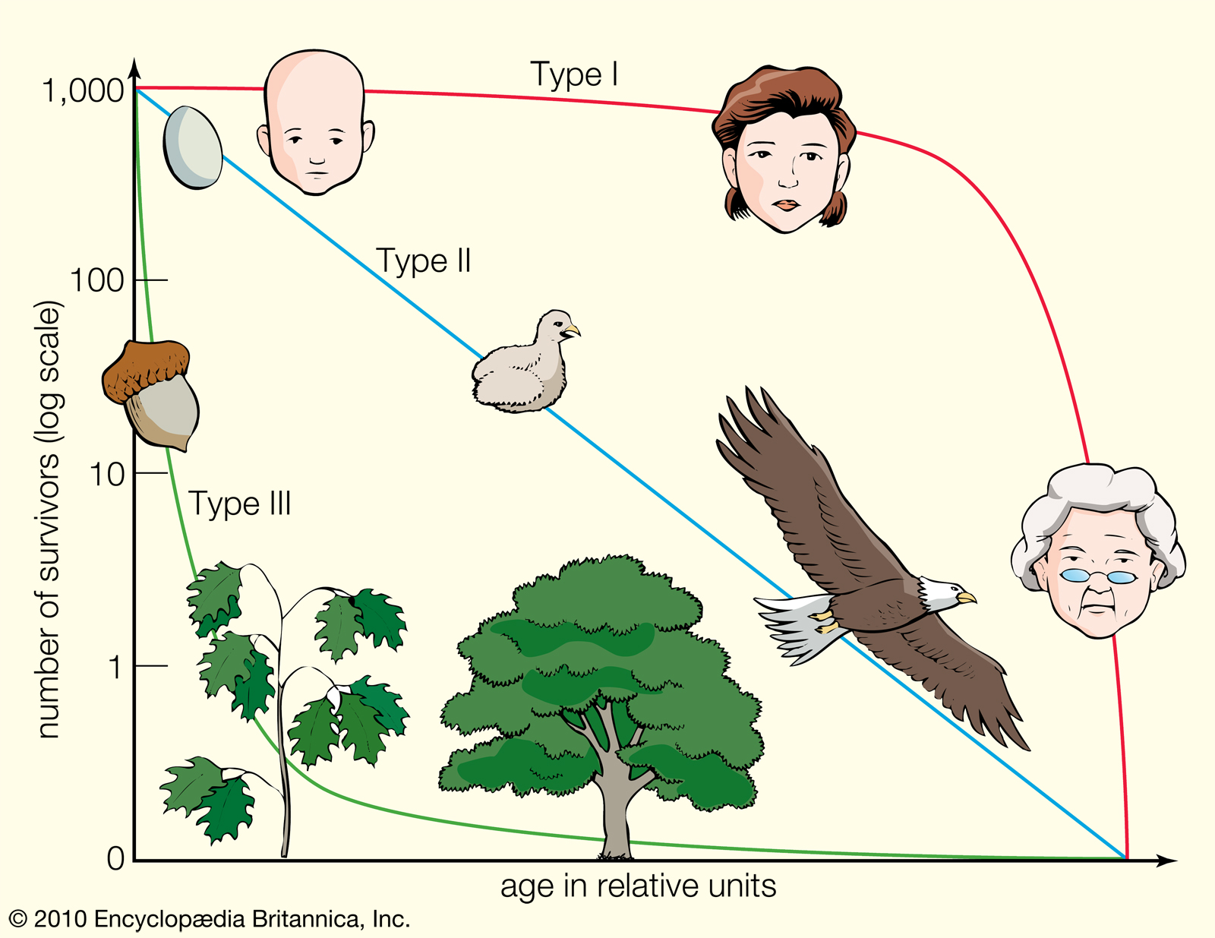

The image above represents the 3 types of survivorship curves. Based on what you see, explain the difference between Type I, Type II and Type III survivorship in terms of mortality (death rate). What are these curves representing?

Explain why human populations might not necessarily show a Type I curve.

Can you provide more examples of organisms that might have Type I, Type II or Type III survivorship curves (other than the organisms represented above)?

How do survivorship curves correspond to r vs K selected species? Explain.

Explain how organisms with a Type III survivorship curve compensate for the high mortality during early life stages.

Describe the features of a species with a Type I survivorship that aid in high juvenile survival.

Discuss the following statement: “There is no standard survivorship curve for a given species; the curve depicts the nature of a population at a particular time and place and under certain environmental conditions.”

